

**Project Title**

Supermarket Billing System

**Description:**

Approaches:

User can add items of following categories:

* Household
* Crockery
* Food etc.

User can edit the entered items

User can delete items

User can generate invoice

User can read data from file through system

Each entered item will written in file

**Outputs:**

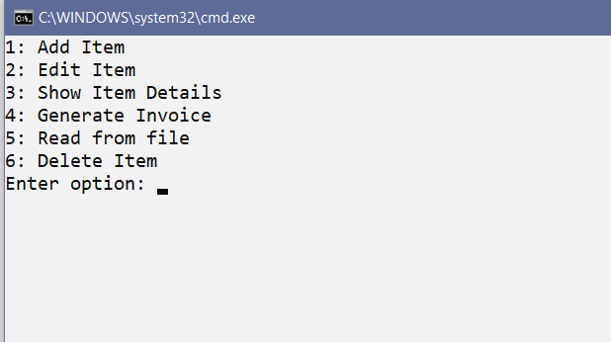

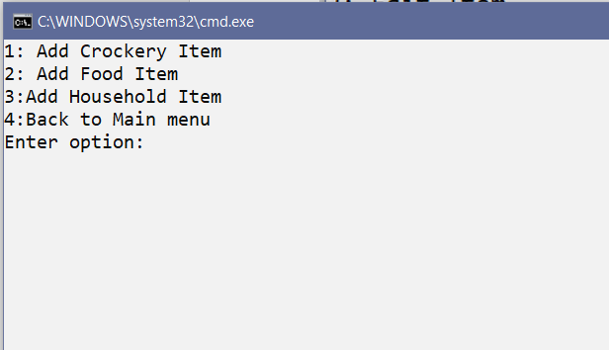

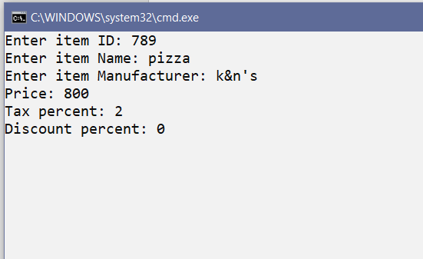

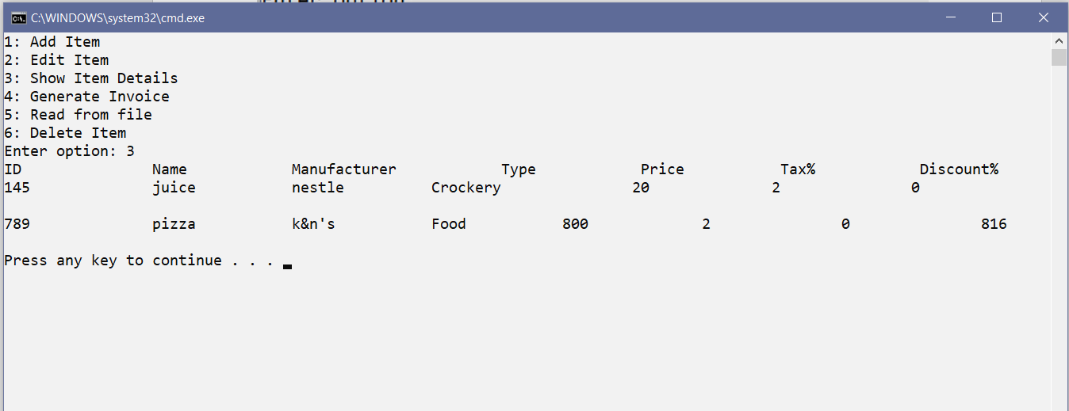

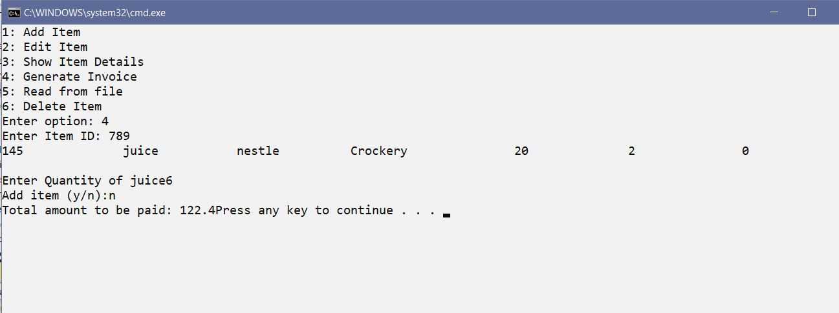

Use Case Diagram:

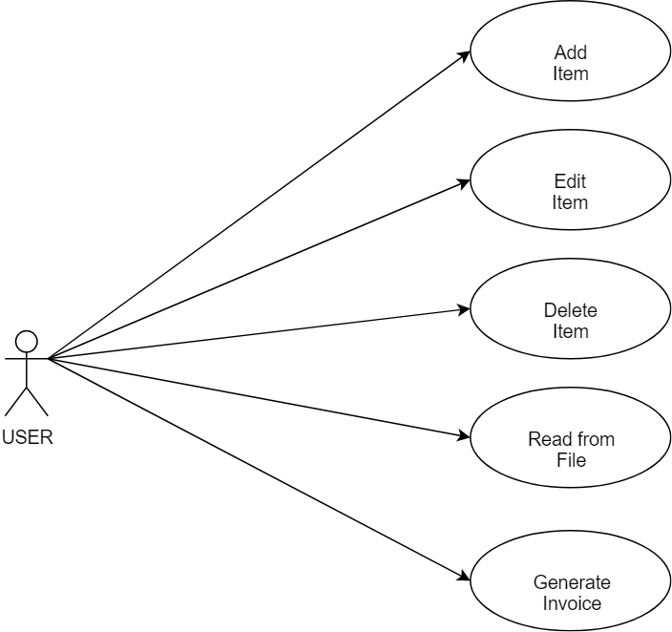

UML Diagram:

